Day 21 - 13th Aug 2026

Node JS

Task 1:
Create a common js module in nodejs to do some arithmetic operation.
9.05 to 9.08

Note:
Common Module JS.
- Key features:
  - Uses require() to import.
  - Uses exports or module.exports to export.
  - Each file is wrapped in its own function scope (variables are private).
  - Supports caching: once loaded, modules are cached for efficiency.
- File types treated as CommonJS:
  - .cjs files
  - .js files if package.json has "type": "commonjs" or no type specified.

Task 2:
Create the same task 1 code using ecmascript.

9.09 to 9.12.
Note:
ES Modules:
- Key features:
  - Uses import and export.
  - Supports top-level await.
  - Better interoperability with modern tooling.
- File types treated as ES Modules:
  - .mjs files
  - .js files if package.json has "type": "module".
Task 3:
Complete 1 to 5 of home tasks.
9.13 to 9.23

Home task qn 6
What is the difference between callbacks, promises, and async/await in Node.js?
10.34 to 10.38

Task 4:
Given 2 files app.js and home.ejs
Can you let me know we are doing in this code.. Give comments for this code in your document.

app.js
// app.js

const express = require('express')
const bodyParser = require('body-parser')
const notes = [{
noteId: 1,
noteContent: "Hey, Prasunamba you can add your important notes here."
}
]

const app = express()

app.set('view engine', 'ejs')

app.use(bodyParser.json());
app.use(bodyParser.urlencoded({
extended: true
}))

app.get("/", function (req, res) {
res.render("home", {
data: notes
})
})

app.post("/", (req, res) => {
const noteContent = req.body.noteContent
const noteId = notes.length + 1;

notes.push({
noteId: noteId,
noteContent: noteContent
})

res.render("home", {
data: notes
})
})

app.post('/update', (req, res) => {
var noteId = req.body.noteId;
var noteContent = req.body.noteContent;

notes.forEach(note => {
if (note.noteId == noteId) {
note.noteContent = noteContent;
}
})
res.render("home", {
data: notes
})
})

app.post('/delete', (req, res) => {
var noteId = req.body.noteId;

var j = 0;
notes.forEach(note => {
j = j + 1;
if (note.noteId == noteId) {
notes.splice((j - 1), 1)
}
})

res.render("home", {
data: notes
})
})

app.listen(3000, (req, res) => {
console.log("App is running on port 3000")
})

home.ejs

<!DOCTYPE html>
<html>

<head>
<title>Note Keeper</title>
</head>

<body>
<h1>Note Keeper</h1>

<div style="display: flex;">

<% data.forEach(element=> { %>

<form action="/update" method="post">
<input type="number" style="display: none;"
name="noteId" value="<%= element.noteId %>">
<textarea type="text" rows="6" cols="30"
placeholder="Type Here..." name="noteContent"
value="<%= element.noteContent %>">
<%= element.noteContent %></textarea>
<br>
<button type="submit">Update</button>
</form>

<form action="/delete" method="post">
<input type="number" style="display: none;"
name="noteId" value="<%= element.noteId %>">
<button type="submit"
style="margin: 0px 4px;">&#10005</button>
</form>
<% }) %>
</div>

<h1>Add Note</h1>
<form action="/" method="post">
<input type="number" style="display: none;"
name="noteId">
<textarea type="text" rows="6" cols="30"
placeholder="Type Here..."
name="noteContent"></textarea>
<br>
<button type="submit">Add</button>
</form>
</body>

</html>

Expected output:

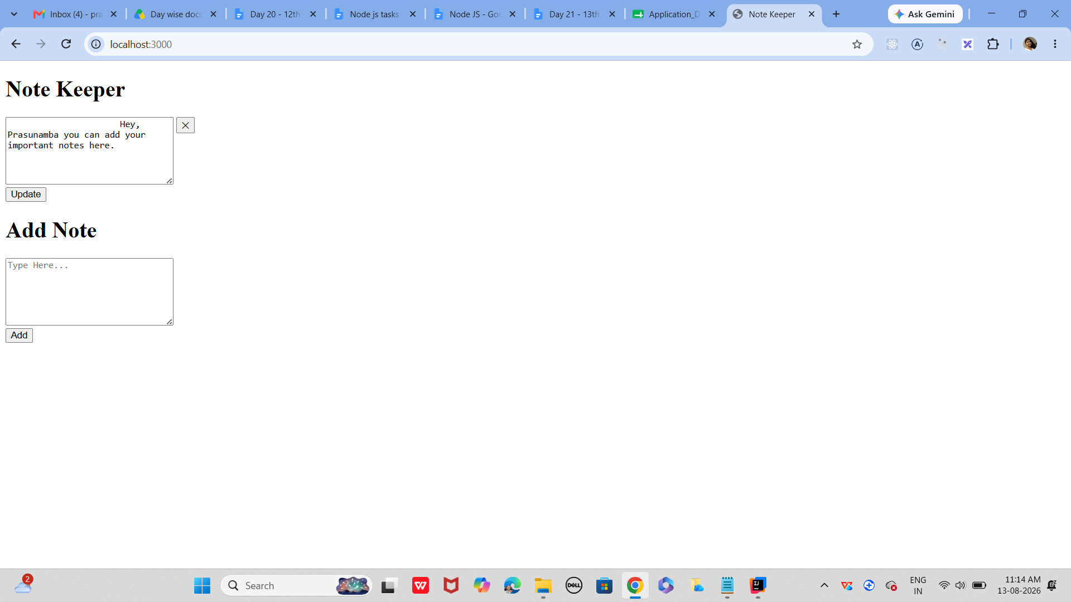

Task 5:
- Import all the required modules like express…
- Initialize the express app
- Create a async function for getting weather.
  - Use await Fetch for `https://api.openweathermap.org/data/2.5/weather?q=${city}&appid=${process.env.WEATHER_KEY}&units=metric`
And assign to response.
  - Now convert response to json..
  - Then return weather info like city , forecast. Temp…etc..
  - Iff any error catch it in catch block
- Next call the web server route.
Like sample
app.get('/weather', async (req, res) => {
const city = req.query.city || "Bengaluru"; // default city
const weatherData = await getWeather(city); // async call
res.json(weatherData); // send JSON response
});

- Finally start the server.

Task 6:
What is Mongoose? What are the key features?why do we use ?

Task 7:
Is this statement true or false?
Mongoose acts as a bridge between Node.js and MongoDB, giving you a structured way to manage your data.
Task 8:
Now in your project
- Import mongoose
- Connect to mongodb
- Lets define a schema..
Like
const userSchema = new mongoose.Schema({
name: String,
age: Number,
email: { type: String, required: true }
});

- Now create a model
const User = mongoose.model('User', userSchema);
- Insert a document
// Insert a document
const newUser = new User({ name: 'Prasunamba', age: 30, email: 'prasun@example.com' });

newUser.save()
.then(() => console.log('User saved successfully!'))
.catch(err => console.error(err));

After lunch

Now once done with Task 8
Task 9:
Create a project structure like this 👍 similar ..

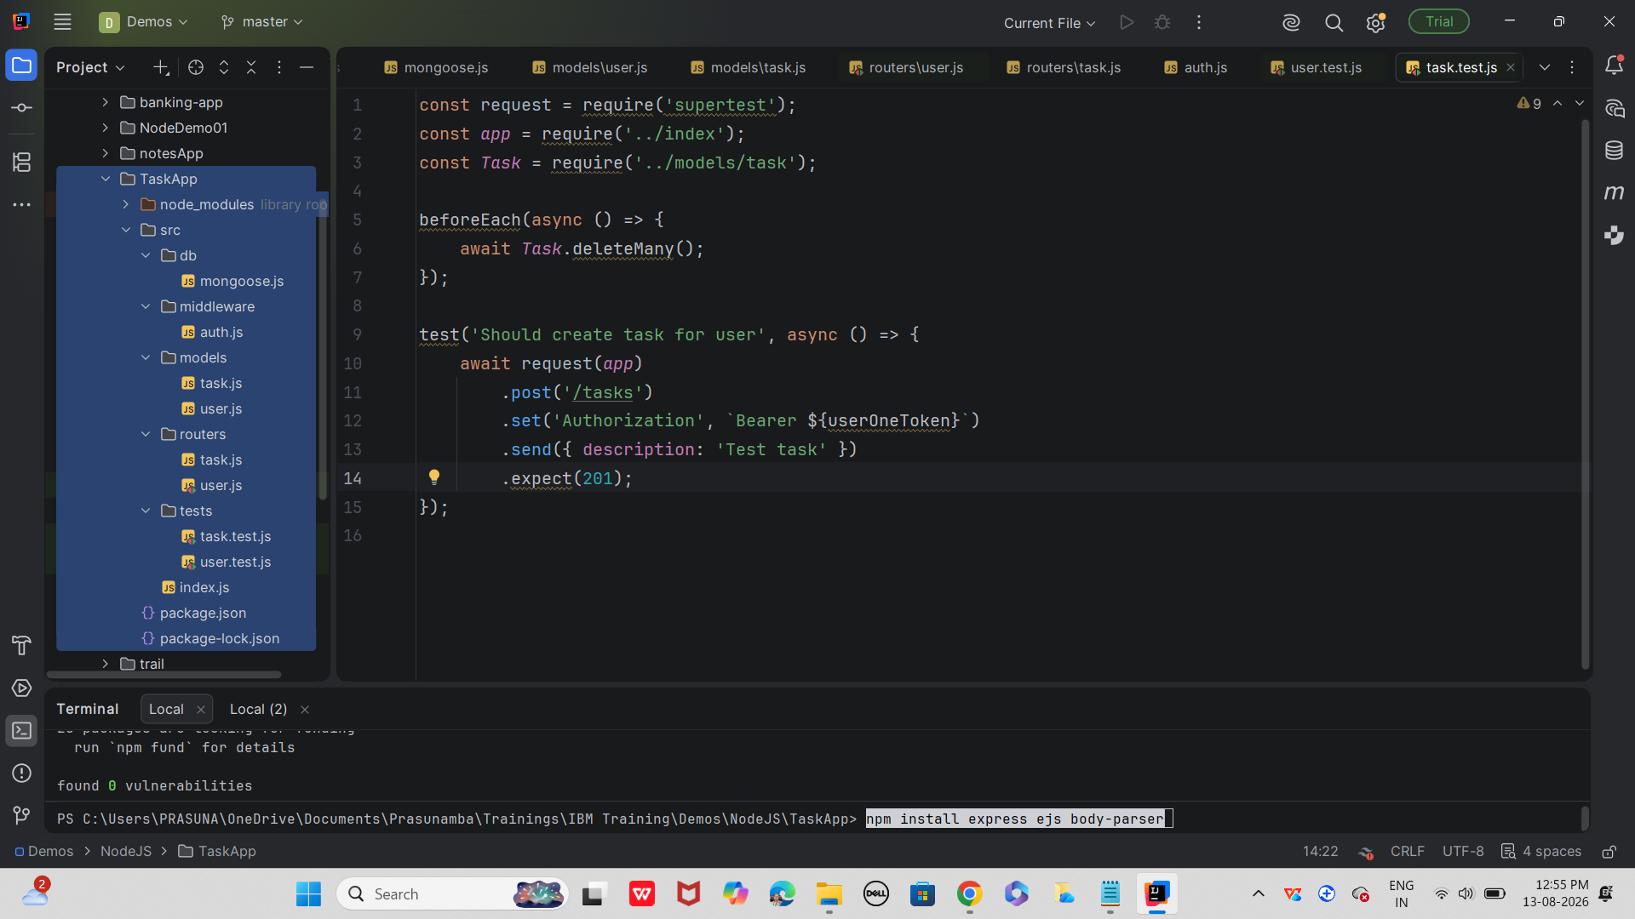

Install dependencies:
In bash
npm install express mongoose bcryptjs jsonwebtoken jest supertest

Start mongo
Start server.. src/index.js
Run tests.. Npm test

index.js
// src/index.js
const express = require('express');
require('./db/mongoose'); // Ensures MongoDB connection is established
const userRouter = require('./routers/user');
const taskRouter = require('./routers/task');

const app = express();
const port = process.env.PORT || 3000;

// Middleware to parse JSON requests
app.use(express.json());

// Register routers
app.use(userRouter);
app.use(taskRouter);

// Start server
app.listen(port, () => {
console.log(`🚀 Server running on port ${port}`);
});

module.exports = app; // Export for testing with Jest & Supertest

Step 1:
File: src/db/mongoose.js
Create mongodb connection with promises.. (success or failed connection)
Juz for reference only ..
const mongoose = require('mongoose');

// Connect to MongoDB using Promises
mongoose.connect('mongodb://127.0.0.1:27017/task-app-api', {
useNewUrlParser: true,
useUnifiedTopology: true
})
.then(() => console.log("✅ Connected to MongoDB"))
.catch((error) => console.error("❌ Connection error:", error));

Step 2:
File: src/models/user.js
- Create user schema
- Ensure hash password before u save
- Generate JWT token as well
Juz fyi.. Only
const mongoose = require('mongoose');
const bcrypt = require('bcryptjs');
const jwt = require('jsonwebtoken');

// User schema
const userSchema = new mongoose.Schema({
name: { type: String, required: true },
email: { type: String, unique: true, required: true },
password: { type: String, required: true, minlength: 6 },
tokens: [{ token: { type: String, required: true } }]
}, { timestamps: true });

// Hash password before saving
userSchema.pre('save', async function(next) {
const user = this;
if (user.isModified('password')) {
user.password = await bcrypt.hash(user.password, 8);
}
next();
});

// Generate JWT token
userSchema.methods.generateAuthToken = async function() {
const user = this;
const token = jwt.sign({ _id: user._id.toString() }, 'secretkey');
user.tokens = user.tokens.concat({ token });
await user.save();
return token;
};

const User = mongoose.model('User', userSchema);
module.exports = User;

Step 3:
File: src/models/task.js
In this
define the Task model using Mongoose, which acts as the blueprint for how tasks are stored and managed in MongoDB.

Schema Definition: It specifies the structure of a Task document (fields like description, completed, createdAt, updatedAt).
Validation Rules: Ensures data integrity (e.g., description must be a string, completed defaults to false).
Middleware Hooks: Can include pre/post-save logic (e.g., timestamps, validation).
Model Export: Makes the Task model available to controllers and services for CRUD operations.
Juz fyi.. Only..
const mongoose = require('mongoose');

const taskSchema = new mongoose.Schema({
description: { type: String, required: true, trim: true },
completed: { type: Boolean, default: false },
owner: { type: mongoose.Schema.Types.ObjectId, required: true, ref: 'User' }
}, { timestamps: true });

const Task = mongoose.model('Task', taskSchema);
module.exports = Task;

Step 4:
File: src/middleware/auth.js
U know what to do….. Here give authentication
Juz fyi only..
const jwt = require('jsonwebtoken');
const User = require('../models/user');

const auth = async (req, res, next) => {
try {
const token = req.header('Authorization').replace('Bearer ', '');
const decoded = jwt.verify(token, 'secretkey');
const user = await User.findOne({ _id: decoded._id, 'tokens.token': token });

if (!user) throw new Error();

req.token = token;
req.user = user;
next();
} catch (e) {
res.status(401).send({ error: 'Please authenticate.' });
}
};

module.exports = auth;

Step 5:then comes
File: src/routers/task.js
Create a task
Filter them .. give pagination, sorting.
const express = require('express');
const Task = require('../models/task');
const auth = require('../middleware/auth');
const router = new express.Router();

// Create Task
router.post('/tasks', auth, async (req, res) => {
const task = new Task({ ...req.body, owner: req.user._id });
try {
await task.save();
res.status(201).send(task);
} catch (e) {
res.status(400).send(e);
}
});

// Get Tasks with filtering, pagination, sorting
// Example: /tasks?completed=true&limit=5&skip=0&sortBy=createdAt:desc
router.get('/tasks', auth, async (req, res) => {
const match = {};
const sort = {};

if (req.query.completed) {
match.completed = req.query.completed === 'true';
}

if (req.query.sortBy) {
const parts = req.query.sortBy.split(':');
sort[parts[0]] = parts[1] === 'desc' ? -1 : 1;
}

try {
await req.user.populate({
path: 'tasks',
match,
options: {
limit: parseInt(req.query.limit),
skip: parseInt(req.query.skip),
sort
}
});
res.send(req.user.tasks);
} catch (e) {
res.status(500).send();
}
});

module.exports = router;

user.js –

const request = require('supertest');
const app = require('../index');
const User = require('../models/user');

beforeEach(async () => {
await User.deleteMany();
});

test('Should signup a new user', async () => {
await request(app).post('/users').send({
name: 'Test User',
email: 'test@example.com',
password: 'MyPass777'
}).expect(201);
});

Step 6:
Now test them with JEST and supertest
File: src/tests/user.test.js
Write test cases..
For user and task…
user.test.js

const request = require('supertest');
const app = require('../index');
const User = require('../models/user');

beforeEach(async () => {
await User.deleteMany();
});

test('Should signup a new user', async () => {
await request(app).post('/users').send({
name: 'Test User',
email: 'test@example.com',
password: 'MyPass777'
}).expect(201);
});

task.test.js
const request = require('supertest');
const app = require('../index');
const Task = require('../models/task');

beforeEach(async () => {
await Task.deleteMany();
});

test('Should create task for user', async () => {
await request(app)
.post('/tasks')
.set('Authorization', `Bearer ${userOneToken}`)
.send({ description: 'Test task' })
.expect(201);
});

Here is the postman.. If you want to refer
Save this as TaskApp.postman_collection.json and import into Postman:
json
{
"info": {
"name": "Task App API",
"_postman_id": "12345-67890-abcdef",
"description": "Collection for Task App with Users & Tasks",
"schema": "https://schema.getpostman.com/json/collection/v2.1.0/collection.json"
},
"item": [
{
"name": "User Signup",
"request": {
"method": "POST",
"header": [],
"body": {
"mode": "raw",
"raw": "{\n \"name\": \"Test User\",\n \"email\": \"test@example.com\",\n \"password\": \"MyPass777\"\n}"
},
"url": {
"raw": "http://localhost:3000/users",
"protocol": "http",
"host": ["localhost"],
"port": "3000",
"path": ["users"]
}
}
},
{
"name": "User Login",
"request": {
"method": "POST",
"header": [],
"body": {
"mode": "raw",
"raw": "{\n \"email\": \"test@example.com\",\n \"password\": \"MyPass777\"\n}"
},
"url": {
"raw": "http://localhost:3000/users/login",
"protocol": "http",
"host": ["localhost"],
"port": "3000",
"path": ["users", "login"]
}
}
},
{
"name": "Get Profile",
"request": {
"method": "GET",
"header": [
{ "key": "Authorization", "value": "Bearer {{token}}" }
],
"url": {
"raw": "http://localhost:3000/users/me",
"protocol": "http",
"host": ["localhost"],
"port": "3000",
"path": ["users", "me"]
}
}
},
{
"name": "Create Task",
"request": {
"method": "POST",
"header": [
{ "key": "Authorization", "value": "Bearer {{token}}" }
],
"body": {
"mode": "raw",
"raw": "{\n \"description\": \"Finish Node.js project\"\n}"
},
"url": {
"raw": "http://localhost:3000/tasks",
"protocol": "http",
"host": ["localhost"],
"port": "3000",
"path": ["tasks"]
}
}
},
{
"name": "Get Tasks (Filter, Sort, Paginate)",
"request": {
"method": "GET",
"header": [
{ "key": "Authorization", "value": "Bearer {{token}}" }
],
"url": {
"raw": "http://localhost:3000/tasks?completed=false&limit=5&skip=0&sortBy=createdAt:desc",
"protocol": "http",
"host": ["localhost"],
"port": "3000",
"path": ["tasks"],
"query": [
{ "key": "completed", "value": "false" },
{ "key": "limit", "value": "5" },
{ "key": "skip", "value": "0" },
{ "key": "sortBy", "value": "createdAt:desc" }
]
}
}
}
]
}

